

|  |
| --- |
|  |
| DRAFT Guidance Document: Preparation of Product Monographs in the Extensible Markup Language Format  *Only for use during the Structured Product Monograph Pilot* |
|  |
| Published by authority of the  Minister of Health |
|  |

|  |  |
| --- | --- |
| Adopted Date |  |
| Effective Date |  |

Health Products and Food Branch



|  |  |
| --- | --- |
| Our mission is to help the people of Canada maintain and improve their health.    Health Canada | The Health Products and Food Branch (HPFB)’s mandate is to take an integrated approach to managing the health-related risks and benefits of health products and food by:   1. Minimizing health risk factors to Canadians while maximizing the safety provided by the regulatory system for health products and food; and, 2. Promoting conditions that enable Canadians to make healthy choices and providing information so that they can make informed decisions about their health.   Health Products and Food Branch |

© Minister of Public Works and Government Services Canada 2014

Également disponible en français sous le titre : Ligne directrice: [INSERT]

**FOREWORD**

Guidance documents are meant to provide assistance to industry and health care professionals on how to comply with the policies and governing statutes and regulations. They also serve to provide review and compliance guidance to staff, thereby ensuring that mandates are implemented in a fair, consistent and effective manner.

Guidance documents are administrative instruments not having force of law and, as such, allow for flexibility in approach. Alternate approaches to the principles and practices described in this document may be acceptable provided they are supported by adequate scientific justification. Alternate approaches should be discussed in advance with the relevant program area to avoid the possible finding that applicable statutory or regulatory requirements have not been met.

As a corollary to the above, it is equally important to note that Health Canada reserves the right to request information or material, or define conditions not specifically described in this guidance, in order to allow the Department to adequately assess the safety, efficacy or quality of a therapeutic product. Health Canada is committed to ensuring that such requests are justifiable and that decisions are clearly documented.

This document should be read in conjunction with the accompanying notice and the relevant sections of other applicable guidance’s.

Document Revision History

|  |  |
| --- | --- |
| **Date (YYYY-MM-DD)** | **Description** |
| YYYY-MM-DD | Phase 1 Release |
|  |  |

Table of Contents

1 Introduction 7

2 Purpose 7

3 Scope 7

3.1 In-scope 7

3.2 Out of Scope 7

4 Policy Objectives 7

5 Background 8

5.1 Extensible Markup Language (XML) 8

5.2 Health Level 7 (HL7) International 8

5.3 Structured Product Label (SPL) Standard 8

5.4 Structured Document 8

6 XML Product Monograph Structure, Content and Concepts 8

6.1 Simplified metadata hierarchy 8

6.2 Output folder structure 10

6.3 Style sheet 10

6.4 Derived Content 11

6.5 Schema 12

6.6 Validation 12

6.7 Controlled Vocabularies 12

6.8 Object Identifiers (OID) 13

7 Template Types 13

7.1 2016 Templates 13

7.2 Legacy Template 13

8 Submission Process 14

8.1 Step 1: Hold technical pre-submission consultation 14

8.2 Step 2: File a sample XML product monograph 14

8.3 Step 3: File the regulatory activity 15

9 Lifecycle Management 15

9.1 Formats 15

9.2 Lifecycle for Regulatory Activities in the eCTD 15

9.3 Lifecycle for Regulatory Activities in the Non-eCTD 17

10 Important Considerations 17

11 Business Conformance Rules 17

11.1 XML prolog 18

11.1.1 XML version and character encoding 18

11.1.2 Stylesheet location 18

11.1.3 Schema location 18

11.2 DOCUMENT METADATA 18

11.2.1 Regulatory Authority (OID 2.16.840.1.113883.2.20.6) 18

11.2.2 Regulatory Activity (Marketing category; templateID OID .11) 18

11.2.3 Submission control number (templateID; OID .49) 18

11.2.4 Document ID (id root; OID .10) 18

11.2.5 Document type (code; OID .10) 19

11.2.6 Document Title (title) 19

11.2.7 Date of Initial Approval (effective time low) and Date of Last Revision (effective time high) 19

11.2.8 Document Language (language code; OID .29) 19

11.2.9 Document Version ID (Set ID) 19

11.2.10 Document Version Number (version number) 19

11.3 ORGANIZATION METADATA 20

11.3.1 Market Authorization Holder (Represented Organization; OID .31) 20

11.3.2 Canadian Importer/Distributor (Assigned Organization; OID .31) 20

11.4 MANUFACTURED PRODUCT METADATA 20

11.4.1 Manufactured Product 20

11.4.2 Ingredients (ingredient substance; OID .14) 21

11.4.3 Packaging 22

11.4.4 Marketing Status 22

11.4.5 Characteristics 23

11.5 NARRATIVE TEXT (PRODUCT MONOGRAPH PART I, II AND III) 24

12 Appendices 24

12.1 Reference documents 24

12.2 Validation Rules 25

**List of Tables**

**Table 1**  **Summary of the six components that make up every XML product monograph** 11

**Table 2**  **Examples of how to present the strength of active ingredients** 23

**Table 3** **Examples of how to present packaging quantity** 23

**Table 4** **Summary of metadata that accompanies all narrative text sections** 25

**List of Figures**

**Figure 1** **Simplified view of the XML product monographs metadata hierarchy** 10

**Figure 2** **Sample file and folder structured for a XML Product Monograph** 11

**Figure 3** **XML before and after the application of a style sheet** 12

**Figure 4** **Source of derived content that makes up the product monographs title page** 13

**Figure 5** **Example of an eCTD lifecycle for the first regulatory activity and its transactions (e.g., NDS or ANDS)** 17

**Figure 6** **Example of an eCTD lifecycle for a subsequent regulatory activity and its transactions (e.g., SNDS, SANDS)** 17

**Figure 7** **Example of an eCTD lifecycle for regulatory activities under simultaneous review** 18

# Introduction

This document serves as the technical implementation guide for the Health Product and Food Branch’s (HPFB) structured product monograph; which is based on Extensible Markup Language (XML), Health Level 7’s (HL7) Structured Product Label (SPL) standard and controlled vocabularies.

This guidance is to be read in conjunction with the *Guidance Document Product Monograph*.

# Purpose

To provide sponsors with guidance on the technical conformance, business conformance and validation rules needed to prepare a product monograph using the XML format and the HL7 SPL standard.

# Scope

## In-scope

* Human pharmaceutical drugs, biologic drugs and radiopharmaceuticals,
* Regulatory activities submitted in electronic format (eCTD or non-eCTD)

## Out of Scope

* Over the counter (non-prescription) drugs, self-care products, natural health products, medical devices, food and veterinary drugs.

# Policy Objectives

In recent years Health Canada announced a number of measures that will be taken to support the health and safety of Canadian families, one of which is improving drug product labels.  As part of the HPFB’s strategic plan, the goal is to:

* Provide more relevant and easier to understand drug information on labels, in order to help Canadians make better informed decisions about their medications; and
* Encourage the adoption of digital health technology to improve access, increase efficiency, and improve outcomes for patients.

As part of this initiative, the HPFB recognized that unstructured formats, like Portable Document Format (PDF), are not adequately positioned to support the objectives mentioned above. We will therefore need to transition to more advanced technology formats. Particular attention will be focused on formats that are open source and supported by international standards.

One such format is XML; a markup language used to encode documents in a structured format that is both human-readable and machine-readable. Since it is an open standard, XML is a widely used format for exchanging electronic documents and data.

With respect to international standards, the HPFB aims to align its use of XML with other international regulators, Health Level 7 (HL7) International standards and the International Organization for Standardization (ISO) standard for the Identification of Medicinal Product (IDMP).

# Background

## Extensible Markup Language (XML)

XML is a text-based markup language used to encode electronic documents in a structured format that is both human and machine-readable. XML is used as a common format to facilitate the interchange of data over the Internet.

XML is a free open standard maintained by the World Wide Web Consortium (W3C).

## Health Level 7 (HL7) International

Founded in 1987, HL7 is a not-for-profit standards development organization dedicated to providing standards for the exchange of electronic health information that supports clinical practice and the management of health services.

Healthcare providers, government stakeholders, payers, pharmaceutical companies, vendors/suppliers, and consulting firms support HL7.

Health Canada is contributing member of HL7.

## Structured Product Label (SPL) Standard

Structured Product Labeling (SPL) is a Health Level Seven International (HL7) standard which defines the content of human prescription drug labeling in an XML format. In the Canadian context, the product monograph is the ‘label’ or ‘the document’ that is being structured.

## Structured Document

In this context, structure refers to the fact that the product monographs content has been encoded with XML; i.e., the content has been ‘markedup’ with XML to make it machine-readable. As a result, the narrative text (e.g., section headings, all text and tables) and product information (e.g., manufacturer, ingredients, dosage forms and packaging) are encoded and can be found easily through search.

# XML Product Monograph Structure, Content and Concepts

## Simplified metadata hierarchy

**Figure 1** is a simplified view of the XML product monographs metadata hierarchy.

**Figure 1 Simplified view of the XML product monographs metadata hierarchy**

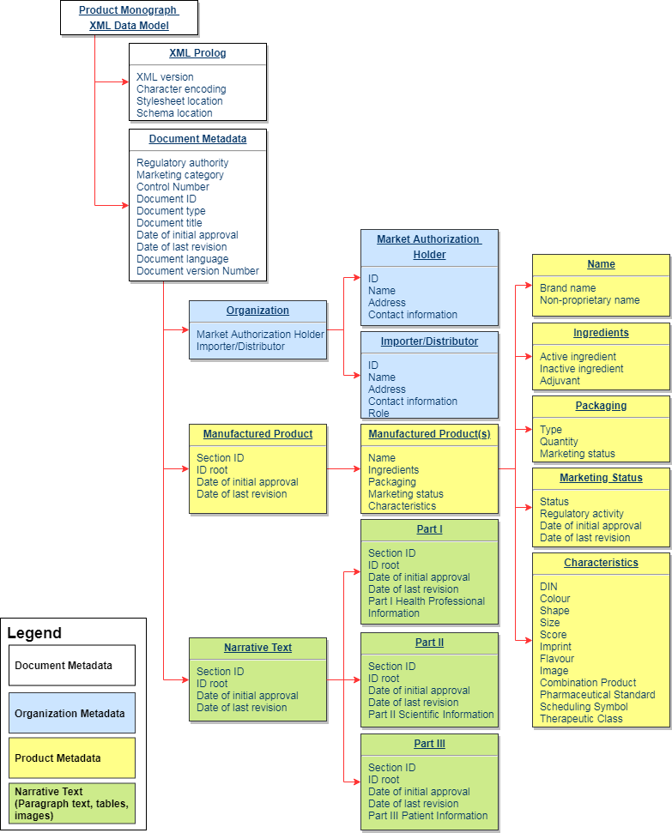

**Table 1** provides a summary of the six components that make up the XML product monograph.

**Table 1 Summary of the six components that make up every XML product monograph**

| **Component** | | **Description** |
| --- | --- | --- |
| 1. | XML Prologue | Instructions to software programs; e.g., XML version, links to the style sheet and schema. |
| 2. | Document Metadata | Identifies the type of document, its unique identifier, its version and its language (French or English). |
| 3. | Organization Metadata | Information about the sponsor; e.g., company name, unique company identifier, address and role. |
| 4. | Manufactured Product Metadata | Brand name, dose form, proper/generic name, active ingredients, inactive ingredients, adjuvants, packaging, unit of presentation, marketing status, route of administration |
| 5. | Narrative Text | Product monograph content (excluding images); e.g., section headings, paragraphs, formatting, text and tables. |
| 6. | Images | Encoded references to all accompanying images; e.g., figures, chemical structure, instructions for use. |

## Output folder structure

XML files end with a .xml file extension and only contain basic text. As a result, the XML product monograph is made up of a single .xml file and separate image files as .jpg’s.

The .xml file contains all text based content, text formatting instructions (e.g., bold, underline, bullets), metadata and references to the relevant image files. Since images are not text they always accompany the .xml as separate files. This is also why the .xml only contains references to images rather than the images themselves.

The .xml and the .jpg’s must always remain together in the same folder to avoid naming clashes with other files and to ensure the .xml file can always find the corresponding .jpeg files.

**Figure 2 Sample file and folder structured for a XML Product Monograph**

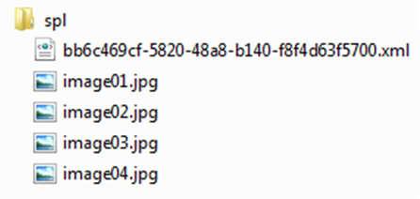

## Style sheet

A style sheet is a file or collection of files that describes how XML content should be displayed; both in terms of appearance and structure. Style sheets do not change or modify the source content in the XML document. The style sheet only modifies how the content is presented to the end user. See **Figure 3** for a simple example.

**Figure 3  XML before and after the application of a style sheet**

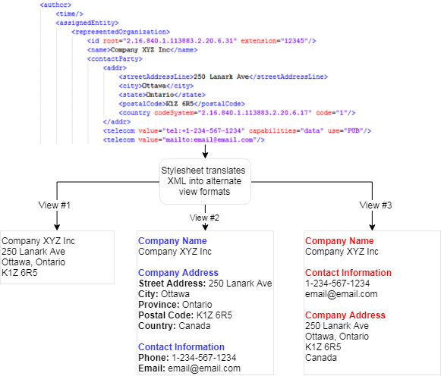

## Derived Content

Another unique aspect of XML documents and style sheets is derived content; i.e., content that exists in the XML but not in the format that is displayed by the style sheet.

E.g., , the product monograph Title Page is automatically generated from metadata and text pulled from throughout the document. The style sheet collates these disparate elements and presents them in a format that end users recognize as the classic product monograph Title Page. See **Figure 4** for a breakdown of how the style sheet generates the Title Page.

**Figure 4 Source of derived content that makes up the product monographs title page**

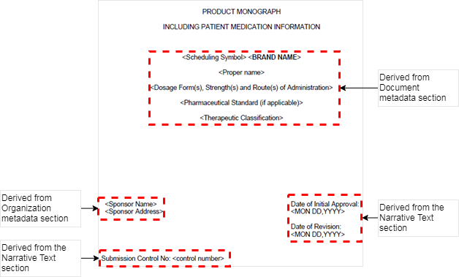

## Schema

The purpose of the schema is to define the key rules and boundaries that the XML document must adhere to. The metadata hierarchy in **Figure 1** is a representative example of the structure that is enforced by HL7’s SPL schema.

The schema goes further by defining how many of a given element the XML document can or cannot have. E.g., , there can only be one XML Prolog section; there must be one or more manufactured products.

## Validation

Validation is the process of checking a XML document against its schema to confirm that it is both well-formed and valid.

A XML document is considered well-formed if it conforms to the W3C’s XML version 1.0 standard.

A XML document is considered valid if it conforms to the schema. In this context the XML product monograph must comply with HL7’s SPL schema.

## Controlled Vocabularies

A controlled vocabulary is an established list of standardized, predefined and authorized terms used for indexing and information retrieval. A controlled vocabulary ensures that a subject will be described using the same term each time it is indexed, making it easier to find all information about a specific topic during the search process. They are controlled using a defined governance model, policies, guidance and change control procedures.

The XML product monograph is accompanied by a set of HPFB approved controlled vocabularies. Use of these vocabularies is mandatory.

The HPFB’s controlled vocabulary list includes, but is not limited to: dosage-form, route of administration, pack type, units of presentation, units of measure, section id, ingredient id, ingredient role.

Refer to the HPFB’s online registry for a full list of controlled vocabularies and their terms.

## Object Identifiers (OID)

OIDs are identifiers based on the International Organization for Standardization (ISO). They are used to name objects or concepts with a globally unique name.

Each of the HPFB’s vocabularies will be registered with HL7 international and assigned a unique OID to facilitate identification, search and retrieval.

2.16.840.1.113883.2.20.6 is the root OID for the HPFB itself. All HPFB controlled vocabularies will use extensions of this OID. E.g., 2.16.840.1.113883.2.20.6.3 (or OID 6.3) refers to the HPFB’s approved list of dosage forms.

All of the HPFB’s controlled vocabularies, and their OID’s, will be posted online to the Health Canada website. From there stakeholders will be able to view or download copies of the approved terms and their attributes.

# Template Types

## 2016 Templates

The XML product monograph supports the following 2016 templates:

1. Product Monograph Template - Standard
2. Product Monograph Template - Notice of Compliance with Conditions
3. Product Monograph Template - Subsequent Entry Product (except for Schedule C and D products)
4. Product Monograph Template - Schedule C
5. Product Monograph Template - Schedule D
6. Product Monograph Template - Schedule D - Biosimilar Biologic Drug

## Legacy Template

The Legacy Template refers to any product monograph template that predates the 2016 templates. i.e., 2014 templates, 2004 templates, pre-2004 templates or any combination thereof.

Since the 2016 template is relatively new, most approved product monographs fall into the legacy template category. The legacy template will allow sponsors to recreate their legacy product monographs in the XML format without compromising the validation rules related to section headings.

However, the Legacy Template cannot be used in lieu of the 2016 templates. The following conditions must be met before being eligible to use the Legacy Template:

* Condition #1 – Pre-existing approved products: New products are expected to begin their lifecycles with the 2016 template. Therefore, only products approved with a legacy template are eligible.
* Condition #2 – No content changes: The XML product monograph is a direct copy of the approved product monograph; i.e., the content in the XML product monograph is identical to the approved version and no content changes have been made.
* Condition #3 – Metadata reflects what is approved: The XML product monograph’s metadata reflects only what is in the approved product monograph; e.g., the XML product monograph metadata cannot include strengths or ingredients not in the approved product monograph.
* Condition #4 – Compliant with the SPL schema: The XML product monograph is compliant with the SPL schema.

# Submission Process

Sponsors filing a regulatory activity with an XML product monograph for the first time are recommended to following this process.

Beyond the first filing, this process is not necessary for subsequent regulatory activities unless there is a significant change. E.g., changes to HL7 specification; changes to the Health Canada specification; sponsor switches to new tool to build the XML product monograph.

## Step 1: Hold technical pre-submission consultation

This consultation is for Health Canada to offer assistance and guidance on the technical, scientific or regulatory aspects of the XML product monograph. This consultation does not need to take place at the same time as the regulatory pre-submission meeting.

Request a consultation by contacting the Business Informatics Division at [hc.dhpr-rmps.sc@canada.ca](mailto:hc.dhpr-rmps.sc@canada.ca). Include the following information in the request:

1. The purpose of the meeting
2. A brief description of the product to be discussed at the meeting
3. Three proposed dates for the meeting, including whether an afternoon or morning meeting is being requested
4. Type of meeting requested, in person, teleconference, or web conference.
5. An agenda for the meeting
6. The names of sponsor representatives attending the meeting

## Step 2: File a sample XML product monograph

Samples are validated by Health Canada to identify and help resolve any issues. Health Canada will notify the sponsor via email if issues are identified; the sponsor corrects the errors and re-submits the sample (this process continues until no issues are identified). If no issues are identified the sponsors XML product monograph should be ready for filing.

This period is not part of and will not delay the review process.

Sponsors can submit sample XML product monographs to the Business Informatics Division at [hc.dhpr-rmps.sc@canada.ca](mailto:hc.dhpr-rmps.sc@canada.ca).

## Step 3: File the regulatory activity

The Sponsor files the regulatory activity with the XML product monograph.

1. Validation: Health Canada validates the XML product monograph to identify any issues.
2. Issues identified: Health Canada will notify the sponsor via email if errors have been identified. The sponsor will correct and re-submit an updated transaction with the corrected XML product monograph (this process will continue until all issues have been resolved).
3. No issues identified: If no issues have been identified, the regulatory activity is processed as per the relevant process.

# Lifecycle Management

## Formats

For the initial regulatory activity (e.g., NDS, SNDS, ANDS, SANDS) product monographs shall be provided in the following formats:

1. Product monograph (clean) – XML format (.xml file and associated .jpg files)
2. Product monograph (clean) – Word format (.docx file)
3. Product monograph (annotated) – Word format (.docx file)

For regulatory transactions submitted during review (e.g., response to request for clarification) product monographs shall be provided in the following formats:

1. Product monograph (clean) – Word format (.docx file)
2. Product monograph (annotated) – Word format (.docx file)

Product monographs shall be provided in the following format within 20 calendar days of the issuance of a Notice of Compliance (NOC):

1. Product monograph (clean) English – XML format (.xml and .jpg files)
2. Product monograph (clean) French – XML format (.xml and .jpg files)

## Lifecycle for Regulatory Activities in the eCTD

Sponsors should use the following eCTD lifecycle attributes to manage Word and XML product monographs under the following circumstances (Refer to **Figure 5**, **Figure 6** and **Figure 7** for examples):

* ‘**NEW**’ when a clean or annotated product monograph is provided as part of the first transaction of a regulatory activity (e.g., NDS, SNDS).
* ‘**REPLACE**’ when a clean or annotated product monograph is provided in response to clarification request, screening deficiency notice (SDN), notice of deficiency (NOD), notice of non-compliance (NON).
* ‘**NEW**’ when a pristine product monograph is provided for the first time. The last clean and annotated draft product monographs should be assigned the operation attribute ‘**DELETE**’.
* ‘**REPLACE**’ when a pristine product monograph is provided to replace a previously approved pristine product monograph. The last clean and annotated draft product monographs should be assigned the operation attribute ‘**DELETE**’.

**Figure 5 Example of an eCTD lifecycle for the first regulatory activity and its transactions (e.g., NDS or ANDS)**

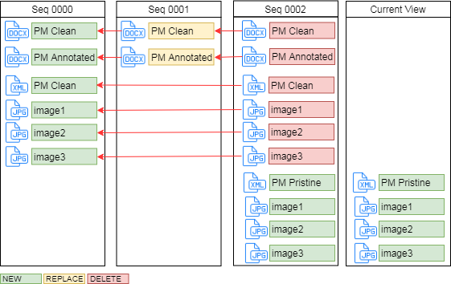

**Figure 6 Example of an eCTD lifecycle for a subsequent regulatory activity and its transactions (e.g., SNDS, SANDS)**

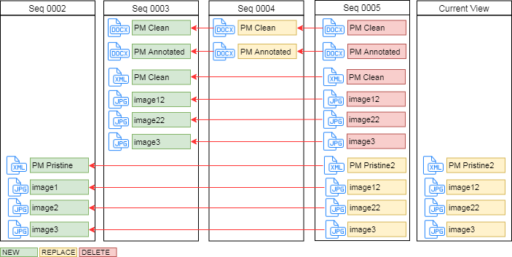

**Figure 7 Example of an eCTD lifecycle for regulatory activities under simultaneous review**

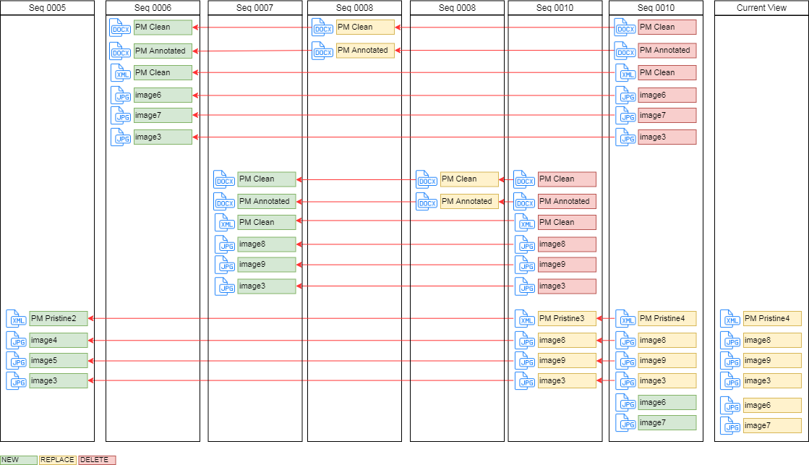

## Lifecycle for Regulatory Activities in the Non-eCTD

Unlike eCTD lifecycles, non-eCTD electronic submissions do not have XML backbones or XML attributes. Therefore, there is no document lifecycle.

Sponsors are only required to submit product monograph files in the formats outlined under section 9.1; i.e., Word and XML with the initial submission, Word only during review and XML only for the final pristine submission.

# Important Considerations

* The XML product monograph is the legal document. The Microsoft Word copies are considered convenience copies to facilitate review.
* Once a sponsor files a regulatory activity with a product monograph in the XML format, all subsequent regulatory activities for the same product monograph must be filed in XML format.
* The HPFB will only provide validation reports for XML product monographs that fail validation. Sponsors are expected to validate the XML product monograph and correct any warning(s) and error(s) before submitting them to the HPFB.

# Business Conformance Rules

The following section provides business, scientific and regulatory instructions for each of the major sections of the XML product monograph (as depicted in **Figure 1** and **Table 1**) and their respective sub-elements.

The heading names for this section use the following format: *Health Canada term (SPL term; controlled vocabulary OID)*.

## XML prolog

This section provides technical data meant for software applications and developers. It is not intended to be modified by sponsors.

### XML version and character encoding

The version of XML in use and the standard for character encoding (i.e., UTF).

### Stylesheet location

Link to the Health Canada stylesheet.

### Schema location

Link to Health Canada’s copy of the HL7 SPL schema.

## DOCUMENT METADATA

### Regulatory Authority (OID 2.16.840.1.113883.2.20.6)

The regulatory authority is ‘HPFB’ and it is specified from the appropriate Health Canada controlled vocabulary.

### Regulatory Activity (Marketing category; templateID OID .11)

The type of regulatory activity associated with this version of the product monograph; e.g., NDS, SNDS, ANDS, SANDS.

Product monographs updated with a Level III Change are not submitted to Health Canada. However, sponsors are expected to keep their XML product monograph up to date with Level III Changes. Sponsors will select Level III Change as the regulatory activity if this version of the product monograph is related to a Level III Change.

Regulatory Activity is specified from the appropriate Health Canada controlled vocabulary.

### Submission control number (templateID; OID .49)

The control number associated with the regulatory activity that led to the approval of this version of the product monograph; E.g., the control number for an SNDS.

Since the control number is not known to the sponsor in advance of filing it can be added to the XML product monograph when the pristine version is filed following the issuance of a NOC.

The submission control number is specified as text.

### Document ID (id root; OID .10)

The Document ID is the unique identifier for this product monograph regardless of the version number.

This Document ID is assigned with the first version of a given product monograph and does not change. The purpose of this ID is to ensure all versions of a product monograph can be tied back to a common parent ID.

Document ID is assigned using a globally unique identifier (GUID); e.g., 123e4567-e89b-12d3-a456-426655440000.

### Document type (code; OID .10)

The type of document is specified; e.g., product monograph - standard or product monograph – schedule D.

The document type is specified from the appropriate Health Canada controlled vocabulary.

Refer to the *Guidance Document - Product Monograph* for further details on the available product monograph types.

### Document Title (title)

The title should include the following information in the following sequence as text:

<Scheduling Symbol> <BRAND NAME> (<common name>), <Dosage Form(s), Strength(s) and Route(s) of Administration>, <Pharmaceutical Standard (if applicable)>, <Therapeutic Classification>

### Date of Initial Approval (effective time low) and Date of Last Revision (effective time high)

Use Date of Initial Approval for a new product monograph. The date is the original NOC date.

Use Date of Last Revision for subsequent revisions to any part of the product monograph. The date is the NOC date from the most recent regulatory activity.

Since the Data of Initial Approval or Date of Last Revision is not known to the sponsor in advance of filing it can be added to the XML product monograph when the pristine version is filed following the issuance of a NOC.

Product monographs updated with a Level III Change are not submitted to Health Canada. However, sponsors are expected to keep their XML product monograph up to date with Level III Changes. In the case of a Level III Change, the Date of Last Revision is the date the Level III Change was finalized by the sponsor.

### Document Language (language code; OID .29)

The language in which the content is based.

Language is specified from the appropriate Health Canada controlled vocabulary.

### Document Version ID (Set ID)

The unique identifier for this version of the product monograph. Unlike the Document ID, the Document Version ID is unique for each version of the product monograph.

The Document Version ID is assigned using a GUID.

### Document Version Number (version number)

The version number for this product monograph is specified as integers.

## ORGANIZATION METADATA

### Market Authorization Holder (Represented Organization; OID .31)

The full legal name, company ID, address and contact information for the sponsor in whose name the Drug Identification Number (DIN) and NOC is to be registered.

*The product monograph is a public document. Therefore, sponsors are advised not to include contact information for an individual. Only include corporate contact information (company website and 1-800 number).*

The legal name of the organization, and its corresponding company ID, are specified from the appropriate Health Canada controlled vocabulary.

Company address and contact information are specified as text.

### Canadian Importer/Distributor (Assigned Organization; OID .31)

If the address of the Market Authorization Holder is NOT located in Canada then the Canadian organization responsible for the sale of this product in Canada must be specified.

The full legal name, company ID, address and contact information for organizations involved in the import or distribution of the active ingredient(s) and drug product(s) associated with this product monograph.

*The product monograph is a public document. Therefore, sponsors are advised not to include contact information for an individual. Only include corporate contact information (company website and 1-800 number).*

The legal name of the organization, and its corresponding company ID, are specified from the appropriate Health Canada controlled vocabulary.

Company address and contact information are specified as text.

#### Role and Product Responsibility

This section specifies the role of the organization (Importer or Distributor) and which of the manufactured products listed in the product monograph they are associated with.

## MANUFACTURED PRODUCT METADATA

This section captures details about the manufactured form of the drug product.

One manufactured product information section is required for each variation in strength, dosage form and formulation.

### Manufactured Product

#### Product Class (template id extension; OID .53)

The type of manufactured drug product is specified from the appropriate Health Canada controlled vocabulary; e.g., biologic, radiopharmaceutical, pharmaceutical, disinfectant.

#### Brand Name (name)

The brand name is specified as text.

#### Dosage Form (form code; OID .3)

The manufactured dosage form is specified from the appropriate Health Canada controlled vocabulary.

#### Nonproprietary Name (name)

The non-proprietary name is specified as text.

The International Non Proprietary Names (INN) is used as Health Canada's standard to assign the preferred name to ingredients.

### Ingredients (ingredient substance; OID .14)

The ingredient, ingredient identifier and role are specified from the appropriate Health Canada controlled vocabulary.

The following sections describe how to manage ingredients, their role and strength/quantity.

#### Ingredient Role – Active (ingredient class code; OID .39)

Active ingredients are specified using one of the following controlled vocabularies:

1. Active Ingredient – Basis of Strength (ACTIB): The ingredient substance is itself the basis of strength. The strength specifies the quantity of the substance in the formulation.
2. Active Ingredient – Moiety is Basis of Strength (ACTIM): The ingredient’s therapeutic moiety is the basis of strength. The strength specifies the quantity of the substance's therapeutic moiety in the formulation.
3. Active ingredient – Reference substance is basis of strength (ACTIR): In situations where the active ingredient has undergone a change in chemical form the therapeutic moiety may be in a different form; e.g., an in-situ conversion of one salt to another salt and the strength is expressed in terms of the active moiety (a base). In this case, another reference substance with the same therapeutic moiety is the basis of strength. The strength specifies the quantity of the reference substance present in the formulation.

Quantity is mandatory for active ingredients

#### Ingredient Role - Adjuvant (ADJV) (ingredient class code; OID .39)

The role ADJV is selected from the Health Canada controlled vocabulary.

Quantity is optional for adjuvants

#### Ingredient Role - Inactive (IACTIV) (ingredient class code; OID .39)

The role IACTIV is selected from the Health Canada controlled vocabulary.

Quantity is optional for inactive ingredients.

#### Ingredient Strength (quantity)

The strength/quantity is specified using a numerator (value and unit) and a denominator (value and unit of presentation).

**Table 2 Examples of how to present the strength of active ingredients**

|  |  |  |  |  |
| --- | --- | --- | --- | --- |
|  | **Numerator Value** | **Numerator Unit (Unit of Measure)** | **Denominator Value** | **Denominator Unit (Unit of Measure/ Presentation)** |
| 10 mg per tablet | 10 | mg | 1 | Tablet |
| 0.2 ml per syringe | 0.2 | ml | 1 | Syringe |
| 2 mg per 5 ml | 2 | mg | 5 | ml |

### Packaging

#### Pack Type (container packaged product form code; OID .32)

The type of packaging is specified from the appropriate Health Canada controlled vocabulary.

#### Packaging Quantity (quantity)

The quantity of the packaging is specified using a numerator (value and unit) and a denominator (value and unit of presentation). The following table provides examples of how packaging quantity is managed.

**Table 3 Examples of how to present packaging quantity**

|  | **Numerator Value** | **Numerator Unit (Unit of Presentation)** | **Denominator Value** | **Denominator Unit** | **Pack Type** |
| --- | --- | --- | --- | --- | --- |
| 10 tablets per bottle | 10 | Tablet | 1 | 1 | Bottle |
| 1 ml per syringe | 1 | mL | 1 | 1 | Syringe |
| 10 syringes per box | 10 | Syringe | 1 | 1 | Box |

### Marketing Status

#### Regulatory Status (Marketing Act; OID .11)

The marketing act refers to the regulatory status of the manufactured product; e.g., approved, cancelled, marketed, dormant. It is specified from the appropriate Health Canada controlled vocabulary.

This regulatory status is equivalent to the status of the product’s DIN(s).

#### Regulatory Activity (Approval; OID .37)

The regulatory activity directly associated with the status; e.g., SNDS, SANDS.

It is specified from the appropriate Health Canada controlled vocabulary.

#### Date of Initial Approval (Effective time low value low)

The effective time low value, or date of initial approval, is specified as a date in the YYYYMMDD format.

#### Date of Last Revision (Effective time high value)

The effective time low value, or date of last revision, is specified as a date in the YYYYMMDD format.

#### Regulatory Authority (territorialAuthority; OID 2.16.840.1.113883.2.20.6)

The authority is always HPFB and is specified from the appropriate Health Canada controlled vocabulary.

### Characteristics

#### Drug Identification Number (template id extension; OID .42)

The DIN assigned to this product by Health Canada can be specified as text.

Since the DIN is not known to the sponsor in advance of filing it can be added to the XML product monograph when the pristine version is filed following the issuance of a NOC.

#### Colour (OID .24)

Where applicable, the colour can be specified from the appropriate Health Canada controlled vocabulary.

#### Shape (OID .25)

Where applicable, the shape can be specified using the terms in the appropriate Health Canada controlled vocabulary.

#### Size

Where applicable, the size or dimensions of the product is specified as text.

#### Score

Where applicable, the imprint can be specified as text.

#### Imprint

Where applicable, the imprint can be specified as text.

#### Flavour (OID .26)

Where applicable, the flavour can be specified as text.

#### Image

Where applicable, a reference to an image can be provided.

#### Combination Product

Where applicable, the type of combination product can be specified from the appropriate Health Canada controlled vocabulary.

#### Pharmaceutical Standard

The pharmaceutical standard is specified from the appropriate Health Canada controlled vocabulary.

#### Scheduling Symbol

The Scheduling Symbol is specified from the appropriate Health Canada controlled vocabulary.

#### Therapeutic Class

The therapeutic classification is specified from the appropriate Health Canada controlled vocabulary.

## NARRATIVE TEXT (PRODUCT MONOGRAPH PART I, II AND III)

This component includes the narrative text of the product monograph; i.e., Part I, II and III section headings, the corresponding sub-headings, paragraphs, lists, tables and formatting instructions (bold, underline, italics). Each section has metadata and content as outlined below:

**Table 4 Summary of metadata that accompanies all narrative text sections**

|  |  |
| --- | --- |
| **Metadata** | **Description** |
| sectionID | the GUID that uniquely identifies a specific section |
| idroot | the GUID that uniquely identifies a specific section |
| Code | the code and OID for the appropriate section heading from the appropriate Health Canada controlled vocabulary (OID .8) |
| Title | the display name of the section heading if it is derived from a controlled vocabulary. If the display name is not derived from a controlled vocabulary it is free text. |
| Text | the free form text, tables, figures, paragraphs and lists. |
| Effective time low value | the Date of Initial Approval |
| Effective time high value | the Date of Last Revision |

# Appendices

## Reference documents

[Guidance Document - Product monograph](https://www.canada.ca/en/health-canada/services/drugs-health-products/drug-products/applications-submissions/guidance-documents/product-monograph/guidance-document-product-monograph.html)

[Guidance Document Questions and Answers: Plain Language Labelling Regulations](https://www.canada.ca/en/health-canada/services/drugs-health-products/drug-products/applications-submissions/guidance-documents/questions-answers-plain-language-labelling-regulations.html)

[HL7 SPL specification](http://www.hl7.org/implement/standards/product_brief.cfm?product_id=440)

[ISO 11615:2017 - Health informatics -- Identification of medicinal products -- Data elements and structures for the unique identification and exchange of regulated medicinal product information](https://www.iso.org/standard/70150.html)

[ISO 11616:2017 - Health informatics -- Identification of medicinal products -- Data elements and structures for unique identification and exchange of regulated pharmaceutical product information](https://www.iso.org/standard/70044.html)

## Validation Rules

| **Metadata Elements** | **Mandatory/ Optional** | **Severity (Error, Warning, Information)** |
| --- | --- | --- |
| XML Prologue | M |  |
| XML version and Character Encoding | M | Error |
| Link to stylesheet files (.xsl and .css) | M | Error |
| Link to schema | M | Error |
| Document Metadata | M |  |
| Regulatory Authority | M | Error |
| Template type | M | Error |
| Marketing category | M | Error |
| Control number | O | Information |
| Document ID | M | Error |
| Document Type | M | Error |
| Document Title | M | Error |
| Date of initial approval | O | Information |
| Date of last revision | O | Information |
| Document Language | M | Error |
| Document version ID | M | Error |
| Document version number | M | Error |
| Organization Metadata | M |  |
| Market Authorization Holder | M | Error |
| Organization Name | M | Error |
| ID | M | Error |
| Address | M | Error |
| City | M | Error |
| Province/State | M | Error |
| Postal Code | M | Error |
| Country | M | Error |
| Phone and email address | O | Warning |
| Importer or Distributor | O |  |
| Name | M | Error |
| ID | M | Error |
| Address | M | Error |
| City | M | Error |
| Province/State | M | Error |
| Postal Code | M | Error |
| Country | M | Error |
| Phone and email address | O | Warning |
| Marketed Product Metadata | M |  |
| Section | M | Error |
| id | M | Error |
| code | M | Error |
| title | M | Error |
| Date of Initial Approval | O | Information |
| Date of Last Revision | O | Information |
| Manufactured Product | M | Error |
| Brand name | M | Warning |
| Generic name | M | Warning |
| Ingredient - Active | M | Error |
| ID | M | Error |
| Name | M | Error |
| Role | M | Error |
| Strength | M | Error |
| Ingredient - Inactive | M | Error |
| ID | M | Error |
| Name | M | Error |
| Role | M | Error |
| Strength | M | Error |
| Ingredient - Adjuvant | O | Warning |
| ID | M | Error |
| Name | M | Error |
| Role | M | Error |
| Strength | M | Error |
| Packaging | M | Error |
| Quantity | M | Warning |
| Type | M | Warning |
| Marketing status | M | Warning |
| Characteristics |  |  |
| DIN | O | Warning |
| Colour | O | Information |
| Shape | O | Information |
| Size | O | Information |
| Score | O | Information |
| Imprint | O | Information |
| Flavour | O | Information |
| Image | O | Information |
| Combination product | O | Information |
| Pharmaceutical standard | M | Error |
| Scheduling symbol | O | Information |
| Therapeutic class | M | Error |
| Marketing Status | M |  |
| Status | O | Warning |
| Regulatory activity | M | Warning |
| Date of initial approval | O | Information |
| Date of last revision | O | Information |
| Narrative Text | O |  |
| Section ID | M | Error |
| Id root | M | Error |
| Section heading | M | Error |
| title | M | Error |
| text | M | Error |
| Date of initial approval | M | Error |
| Date of last revision | M | Error |
| Referenced Files | O |  |
| ID | M | Error |
| text | M | Error |
| Referenced file type | M | Error |
| File path to referenced file | M | Error |